Lab-11: Applications of DIP

**Task (A):**

Considering that you are a digital Image processing expert, can you suggest the steps (and, of course, show the results experimentally) for moving from image “a” to image “b” as given below. You already have studied a compendium of approaches that can help you out here. Trying to be unique and still getting the results – may help you get good marks.

Note: You can apply your algorithm on the image (ThumbImpression.png) given to you separately in this lab, but the results should be depicting the similar concept as provided in image “b” below.

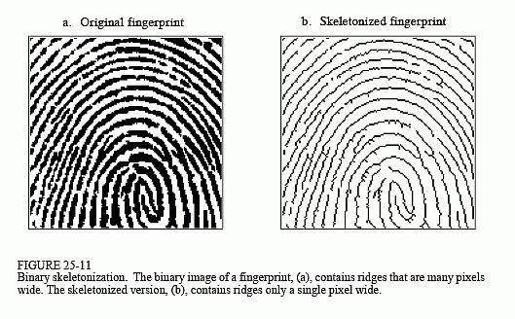 

“a” “b”

**Task (B): Application**

Take image of a handwritten signature and perform the following tasks: (Input signature is provided as a single image separately – Signature.png)

1. Develop a bounding box around the signature content.
2. Find out the centroid of the signature.
3. Segment signature from centroid vertically and horizontally (the signature will be divided into four pieces)
4. Calculate black to white transitions for each of the four segments.

# Description

In this section, we will walk through the lab tasks and see how to complete them. This walkthrough is to provide you a starting point for your own implementations, and hence is abstract and leaves out many implementation details. You are supposed to figure them out yourself. The input image is,



## Preprocessing

Convert the signature to a binary (black-and-white) image before extracting features. With PIL, this can be done by using the Image.convert() method. For further information on how to use PIL, refer to PIL handbook at <http://www.pythonware.com/media/data/pil-handbook.pdf>. At this point, your signature image should look like this:



## Task 1: Developing a bounding box

In this task, you have to locate the signature in the image and develop a bounding box around the signature content only, ignoring the white space around it.

**Algorithm**

left := width

right := 0

top := height

bottom := 0

for x in (0, width) and y in (0, height)

color := image.getpixel(x, y)

if color is 0

if x > right

right := x

if x < left

left := x

if y > bottom

bottom := y

if y < top

top := y

After completing this task, your signature image should look somewhat like this:



## Task 2: Locating the centroid

Centroid is the point where center of mass of the signature image is located (It is not necessarily the center of an image). It can be computed using the algorithm given below.

**Algorithm**

cx := 0

cy := 0

n := 0

for x in (0, width) and y in (0, height):

if image.color(x, y) is 0:

cx := cx + x

cy := cy + y

n := n + 1

cx := cx / n

cy := cy / n

## Task 3: Dividing the image at centroid to create four segments

You should have the following at this point:

1. Bounding box = (left, right, top, bottom)
2. Centroid = (cx, cy)

You now have to divide the image into four segments. The four segments can be computed by locating the boundaries of each of the four segments:

1. (left, cx, top, cy) are the boundaries of top-left segment
2. (cx, right, top, cy) are the boundaries of top-right segment
3. (left, cx, cy, bottom) are the boundaries of bottom-left segment
4. (cx, right, cy, bottom) are the boundaries of bottom-right segment

After completing this task, your signature image should look somewhat like this:



## Task 4: Finding black to white transitions

In this lab task, you have to find black to white transitions for each of the four segments/ blocks of the signature you made in Task3. That is, you have to calculate the number of white pixels in the neighborhood (use 8-connectivity) of each black pixel in the image. For details about pixel connectivity, refer to your famous friend 

**Algorithm**

prev := image.color(0,0)

n := 0

for x in (1, width) and y in (1, height):

curr = image.color(x,y)

if curr is 255 and prev is 0

n := n + 1

prev := curr

## Completion check

On successful completion of the lab tasks, you should have the following:

1. Bounding box of the signature in image
   1. B = (left, right, top, bottom)
2. Coordinates of centroid of the signature
   1. C = (cx, cy)
3. Four values of black to white transitions, for each of the four segments
   1. T = (TL, TR, BL, BR)

# Deliverables

Submit your source code on LMS in a compressed file. Your submission should follow the following naming convention: YourName_RegNo_Section